Romatech ICT Solutions

info@futballmoney.com

Abstract

FutballMoney works with time sharing a match.   
Which means a user can watch and predict a match.

Futballmoney

Make Cool Money From Watching Live Soccer Match On Your TV.



FUTBALLMONEY (MANUAL)

What is Futballmoney.com?

Futballmoney is a legalized soccer prediction site where users predict on live matches and the right users who gets the prediction correctly wins the cash money. Futballmoney works with time sharing a match Which means a user can watch live soccer match while on the same time predict to win real cash.

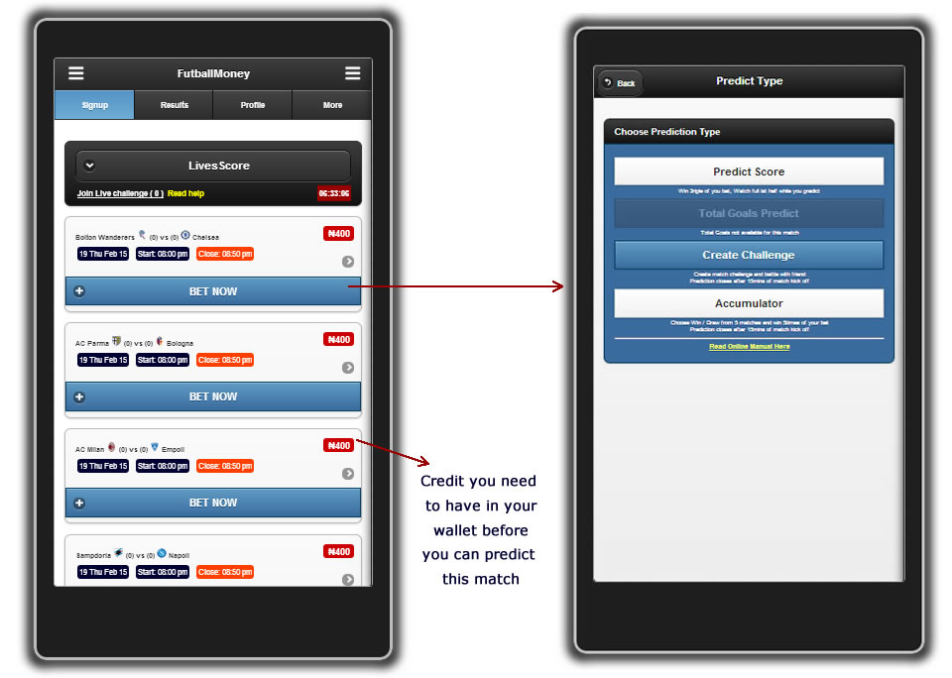

http://futballmoney.com/video/manual.docx

## How can one join futballmoney?

To join futballmoney is free; all you have to do is click link below.

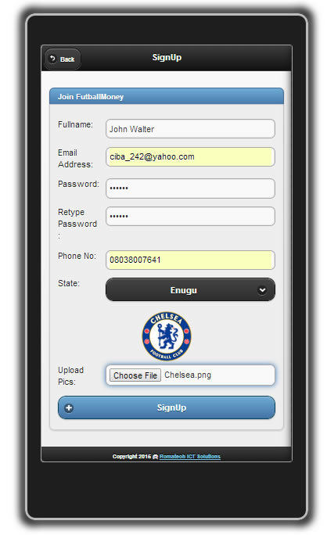<http://futballmoney.com/signup.php>

Note:

To join futballmoney make sure you have a valid email address and phone number because this will enable you to activate your account creation.

### What makes futballmoney unique?

In futballmoney, you can watch the live soccer while you predict to win.

## Futballmoney have 6 type of prediction Categories

1. Predict Score (PS) : 3 odds
2. Total Goals Predict (TGP) : 2 odds
3. Create Challenge (CC)
4. Accumulator (AC) : 5 odds
5. Max Score (MS) : 7 odds
6. Max Total Goals (MTG) : 4.5 odds

### Let’s explain each type of prediction categories

## **Predict Score**

Watch full Ist half and predict the score line to win money. Make sure you predict score line before 50 minutes of the match elapses. You can only predict twice per match. Here you win triple times of your every bet.

Eg.

MAN UTD (2) vs (1) EVERTON

PREDICT SCORE INTERFACE

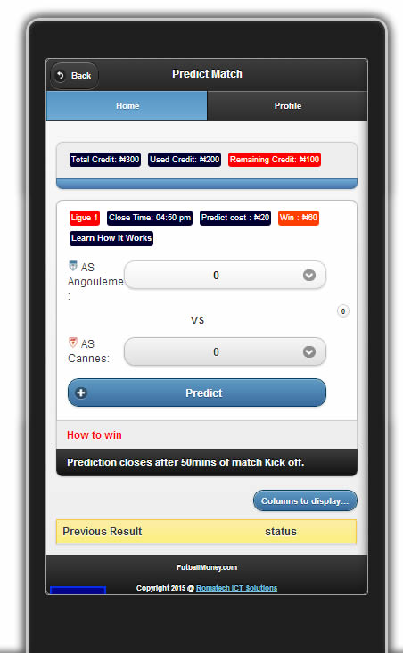

Win 3riple of your Bet

Example

In predict score watch full Ist half while you predict. Prediction time closes after 50 minutes of match kick off.

Eg: let say you predicted with ₦200 after the match you get the score correctly, then you just won ₦600.

₦200 x 3 = ₦600

Win 3riple of your Bet

### **Total Goals Predict (TGP)**

Watch Full 15mins of First Half of a live soccer game, predict the total goals and win triple of your bet.

All you have to predict is 3 Goals, 4 Goals etc.

It doesn't matter if they play 2:1 or 3:1 just say the total goals of a match and win twice amount of your bet. You can only predict once per match.

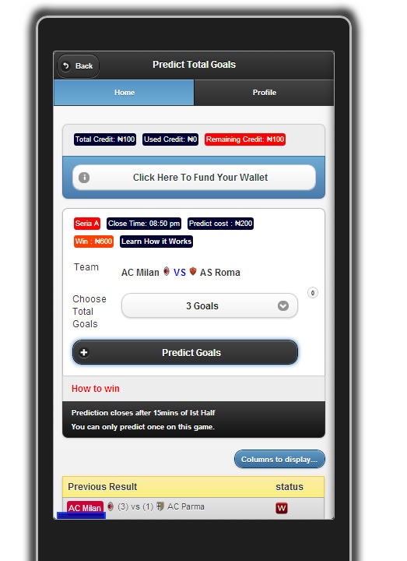

Win twice of your Bet

This table shows their previous matches results.

Example

In predict total goals you can watch only 15mins of Ist half while you predict the total goals to be scored on the match. Prediction time closes after 15 minutes of match kick off.

Eg: let say you predicted with ₦500 after the match you get the total goals scored correct, then you just won ₦1000.

₦500 x 2 = ₦1000

Win twice of your Bet

### **CREATE CHALLENGE (CC)**

BE A TRUE FAN, CHALLENGE YOUR FRIENDS TO A BET



Battle of challenge is a new game line which you can play with your friend. This game requires only 2 people before it is valid. In Battle of challenge you create a challenge on any live match available on futballmoney homepage.

The first person to create a challenge is the challenge creator, which only he can set the price pertaining to that challenge. He can then throw up the challenge to his friends to battle with him.

You can throw up the challenge to your friends through social networks eg (Facebook, Twitter, Email) .etc. or through SMS, which has been provided for you by FutballMoney..

**HOW TO CREATE A CHALLENGE**

In battle of challenge you don't need to predict the exact score line rather you choose the Outcome of WIN or DRAW. You can only choose one outcome per match challenge.

The price per match challenge will be determined by the user that created the challenge.

You can create as many challenge on different matches as possible.

Game of challenge requires two people inorder to be a valid game.

15 minutes: Maximum time for all challenges to end after match kick off.

₦200 is the least amount you need to create a challenge

CHALLENGE INTERFACE

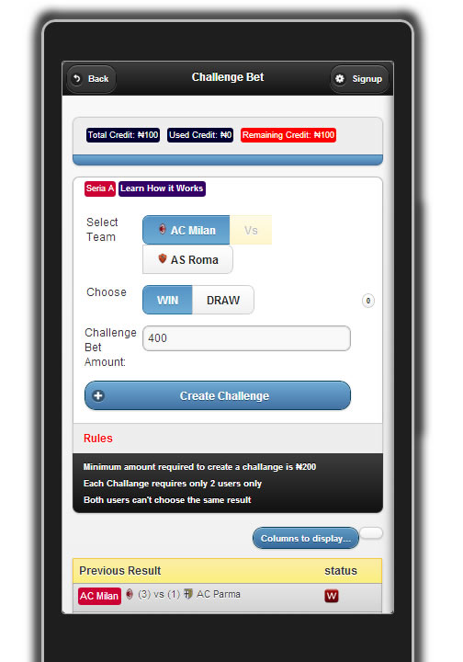

Set the Price for this Challenge as the creator

# **BATTLE OF CHALLENGE RULES**

1. The least amount required to create a challenge is ₦200
2. The maximum time all challenge will end is 15minutes after match start time
3. Each challenge requires only 2 users only
4. Two users can’t choose the same result altogether
5. You can only choose one out come per challenge (WIN / DRAW)
6. Invite friends to challenge SMS module cost ₦3 per sms from your wallet.
7. If you created a challenge and throws it up to friends and nobody accepted the battle after the match we will refund your money back to your wallet.
8. If you created a challenge and someone accepted and play with you after the match the winner received the 90% of the total money.
9. If both of you lose the challenge the money each staked will be returned to his wallet, but futballmoney will discount 5% off from it.

## WIN 90% OF YOUR TOTAL CHALLENGE BET

For instance you create a challenge of ₦400

Chelsea Vs Arsenal

And some accepted and played the challenge with you. Then the Total challenge amount now is ₦800 the winner of the challenge will get ₦720

(90% of Total Amount).

## **FAQ'S**

1. What is the minimum & maximum amount to create a challenge match?

Answer: *The least amount to create a challenge is ₦200 and above*

1. If nobody challenges you and your prediction happens, will you be a winner?

Answer: *if nobody accepts your challenge it is void, we refund your money back into your wallet even if you lose or get the prediction in the challenge*.

1. How much will you win if you play with an amount e.g ₦400?

Answer: *In battle of challenge you win 90% of the total money involved on the challenge.*

For instance you create a challenge of ₦400 Chelsea Vs. Arsenal

And some accepted and played the challenge with you. Then the Total challenge amount now is ₦800 The winner of the challenge will get ₦720 (90% of Total Amount)..

₦200 is the least amount you need to create a challenge

1. Does it still give us 3 points regarding the ongoing EPL Leadboard Challenge Game?

*Answer: Sure, create a challenge on premier league win and get your 3 point on the EPL leadboard game.*

1. What if both of us lose the challenge what will happen to our stake?

*Answer: If both of you lose the challenge the money each staked will be returned to his wallet, but 5% will be discounted off from it.*

1. What is the maximum number of people that can play a particular challenge?

*Answer: Two can only play this game per challenge, but you can create as many challenges as possible*

### **ACCUMULATOR (ACC)**

In accumulator game, you will be given 6 matches at random to choose WIN or DRAW options, while you place a total amount for the stake.

The real challenge in the accumulator game is to win all the 6 matches predictions! Predict 6 matches correctly and you are automatically a winner, winning total odds times amount staked.

Note, you will still qualify on Leadboard Game Show, whenever you win accumulator stake pertaining to the league selected by futballmoney. Any Accumulator match won will give you 2 point only. eg (Premier, La Liga, Seria A etc)

**PLAY ACCUMULATOR**

Login to <http://futballmoney.com>

On our homepage and click on any match, and select 'Accumulate' which will generate 5 matches at random for you to play

**ACCUMULATOR STAKES**

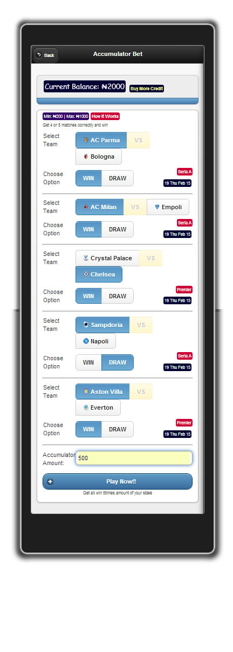Place your Stake by choosing either a 'win' or a 'draw' in each of the 5 matches shown

**TIPS ABOUT ACCUMULATOR BETS**

Betting on Accumulator matches closes 15 minutes after match Kick off:

To win in an accumulator stake, you must get all the 6 matches prediction correct.

6 Points: This is when you get all the 6 matches prediction correctly. It is called a 'Jackpot'.

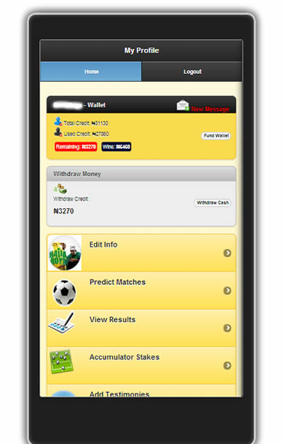**VIEW YOUR ACCUMULATOR RESULTS**

After placing your bets, you can view your status by login in to your profile and clicking 'Accumulator Stakes'

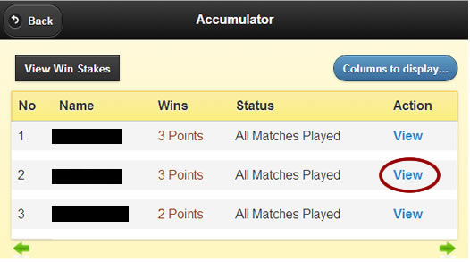

**STAKE WINNER**

This table shows you the results of the individual accumulator matches you have bet on, the total matches won and how much you have won.

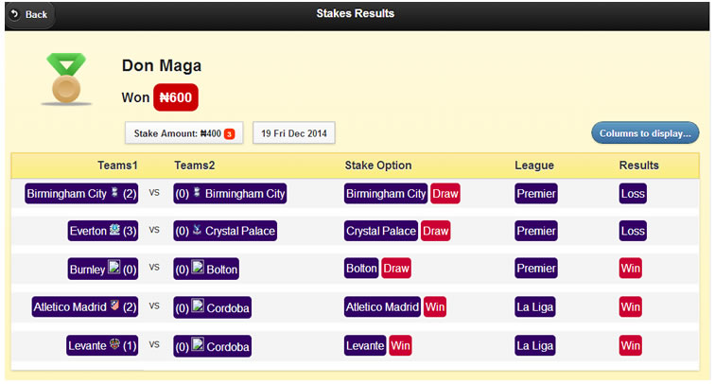

**HOW TO CALCULATE YOUR ACCUMULATOR WINS**

Let’s say you stake ₦500, this is what happens if you Win all the 5 Matches from the Accumulated Match Stake

Win 6 Matches (14.00 odds)

Total Odds * Amount Staked = Amount Won

14.00t * ₦500 = ₦7000

ACCUMULATOR RULES

1. 6 matches are generated randomly for you to choose either 'Win' or 'Draw' options
2. The Mininum amount to stake in accumulator is ₦200, Maximum amount is ₦10,000
3. In accumulator, once 1 out of your 6 predictions go wrong, everything goes wrong, you need to get all the 6 predictions matches correct then you are listed as a 'Winner', and you win total odds * the amount staked.
4. When any match out of the 6 staked matches is yet to be played, the accumulated match stake is classified as 'Pending' untill all 6 matches are played.
5. Any Accumulator match won will give you 2 point only on EPL Leadboard

# FINAL MATCH RESULTS

View the winners of the final matches’ results by clicking on “Results”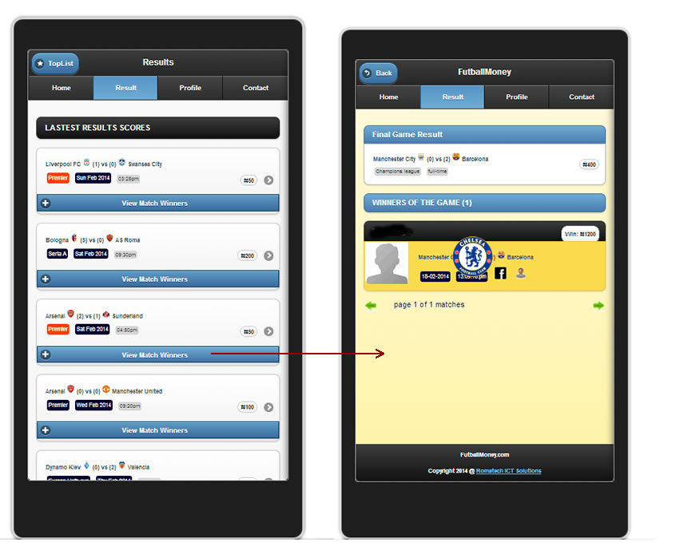

### **MAX SCORE (MC)**

Here you will be given 2 matches at random to predict the exact scoreline of the matches, while you place a total amount for the stake.

In order to win you must get the scoreline of the two random matches score result correctly. 7 is the odd here, which means the amount to be won is equal to 7 * amount staked for the match. Which means the higher the money staked the higher the amount to be won.

Note, you will still qualify on Leadboard Game Show, whenever you win max score matches stake pertaining to the league selected by futballmoney. Any match won will give you 3 point only. eg (Premier, La Liga, Seria A etc).

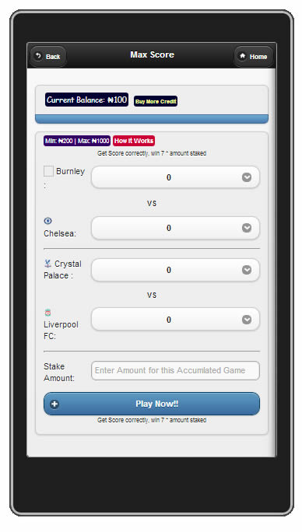

Here, Predict the score of two random matches and win 7 * amount staked.

### **MAX TOTAL GOALS (MTG)**

Here you will be given 3 matches at random to predict the total goals to be scored in each match, while you place a total amount for the stake.

In order to win you must get the total goals of the 3 random matches result correctly. 4.5 is the odd here, which means the amount to be won is equal to 4.5 * amount staked for the match. Which means the higher the money staked the higher the amount to be won.

Note, you will still qualify on Leadboard Game Show, whenever you win max total goals matches stake pertaining to the league selected by futballmoney. Any match won will give you 3 point only. eg (Premier, La Liga, Seria A etc).

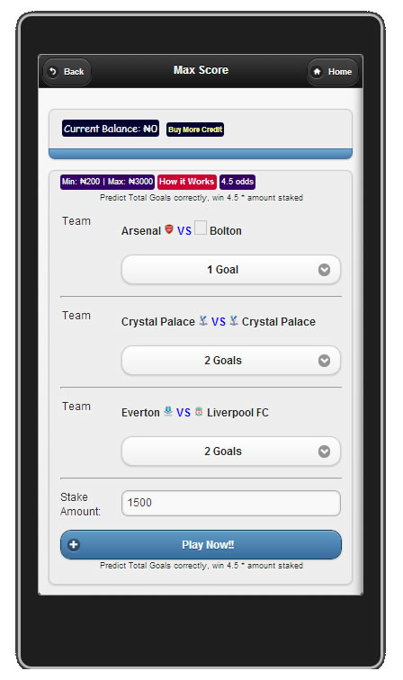

Here, Predict the total goals of three random matches and win 4.5 * amount staked.

## MY PROFILE

Whenever you login using your registered phone number and password successfully, you will be taken to your profile.

Your profile is a control panel where you manages everything you do on futballmoney eg. It shows your current balance amount, edit info, referral agent and withdraw cash.

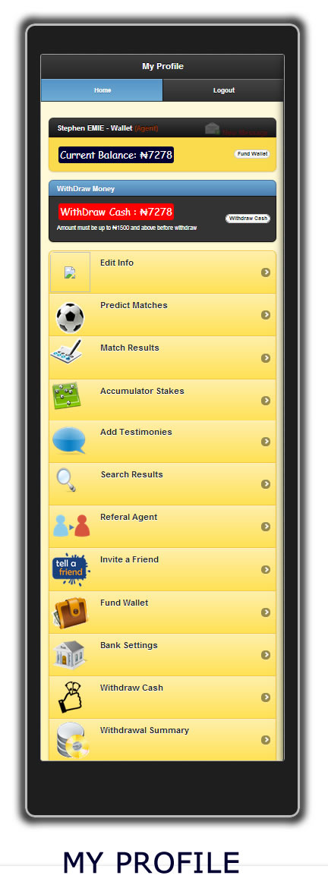Profile Interface looks like this:

PROFILE FEATURES

Edit info: Change your personal details here e.g. Password, picture, state, Facebookurl& bbmpin.

Predict Matches: This shows available match for you to bet on and win money.

Accumulator Stakes: Check all your predicted accumulator stakes matches results and status here.

Add Testimonies: Add or Read different testimonies from different people about futballmoney.

Referral Agent: Refer 5 of your friends to join futballmoney and win money by sharing you referral link on social media.

Fund Wallet: Add more money to your account wallet for match predictions.

Bank Settings: State your bank details here for bank transfer of fund when you withdraw your money off from wallet using bank method.

Withdraw Cash: Withdraw your money off from futballmoney by either selecting Recharge Card Method or Bank Transfer Method.

Withdraw Summary: View all active and pending withdraws status made from your futballmoney account.

## **HOW TO WITHDRAW YOUR MONEY**

## **FROM FUTBALLMONEY ACCOUNT**

Use any of the two methods below:

1. Phone Recharge Card Method
2. Bank Transfer Method.

Recharge Card Transfer:

Enter the amount to be recharged in the space provided for 'Withdraw Amount'. The amount entered will be sent to your Mobile Phone number as Recharge Card using your registered phone number.

Bank Transfer Method:

Enter the amount to be withdrawn in the space provided for 'Withdraw Amount'. The amount entered will be wired into your registered bank account details specified in the 'Bank Settings' tab on your Profile.

# How to withdraw cash from your futballmoney account.

To withdraw your money off from futballmoney website, firstly login to your profile and click on ‘Withdraw Cash’ button, enter the amount you what to withdraw and the type of transfer you want.

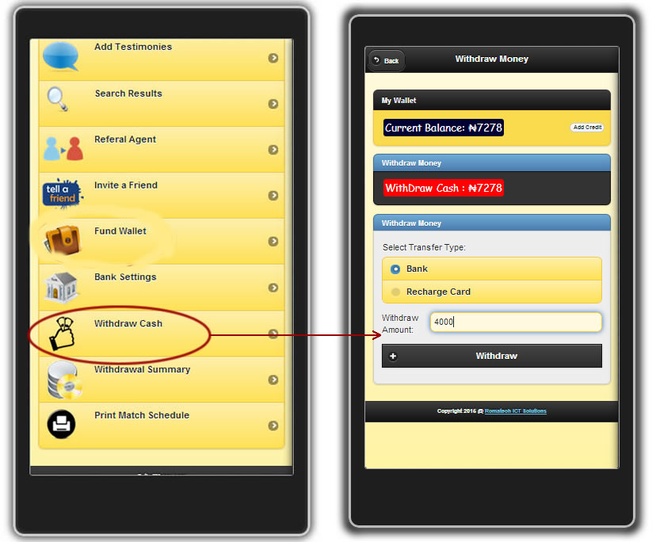

After your withdraw process and is done successfully, We futballmoney will then transfer the equvilvant amount to you either through Recharge card or bank transfer following your desire selection on the transfer type method .

## **HOW TO FUND YOUR FUTBALLMONEY**

## **WALLETACCOUNT**

Use any of the two methods below:

1. Phone Recharge Card Method
2. Bank Transfer Method.

Bank Transfer Method:

1. Pay ₦1000 and above into our bank account.
2. Note: In the Bank Teller -
3. Name of Depositor use your Registration Email Address
4. After your payment have been confirmed. The 12 Digit Activation Recharge Code will be send to your Mobile phone and your Email address.

GTB Bank Details

**Acct_Name:** ROMATECH ICT SOLUTIONSLIMITED

**Acct_No:** 0127926031

**Depositor Name:** Use Your Registration Email



**FUND YOUR FUTBALLMONEY WALLET USING RECHARGE CARD METHOD**

Fund your FutballMoney account by sending MTN / GLO recharge card to our mobile numbers listed below:

₦100, ₦200, ₦400 or ₦500 and above into our listed Phone Numbers.

**MTN: 0810-297-7474**

**GLO: 0815-999-7140 (Add Us OnWhatsapp)**

**PIN: 2BA0DD59**

Immediately, after your payment has been confirmed. The 12 Digit Activation Code equivalents to the amount you send will be forwarded to your Mobile phone and your Email address.

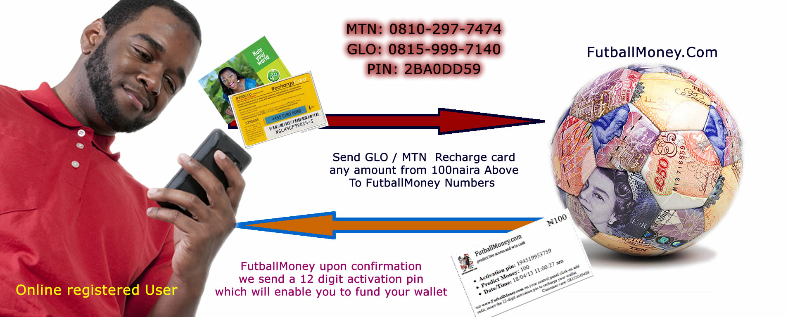

# TIPS

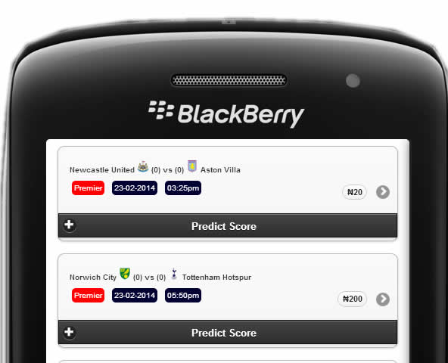

Amount you need to have in your profile account wallet before you can bet on this match

Betting Amount

Time indicates when the prediction power of this match will close which is 60mins of the game

Closing Time

Assuming Norwich City wants to play TottenhamHospur by ₦200 , this means before you can predict on this match youmust have at least ₦200 in your futballmoney wallet account, and you can watch the live game before you can predict the scoreline, which you have between thematch starting time to 50mins of the game to predict before the prediction door closes.

In Futballmoney Predict Score, you win triple of your bet. eg.

Bet with ₦500 - win ₦1500

Bet with ₦1000 - win ₦3000

Futballmoney Online betting doesn’t work like others, which in order to increase your income you have to accumulate series of matches together. Once one of your picks go wrong, everything goes wrong. But with, Futballmoney you win triple of your bet on any match you predict on.

Pretty easy, more lucrative...

## How to Check Your Bet History

In case you want to take a look at the matches you have played, you can check your history. Just click on View Result Tab on your Profile of the site after you have logged in.

There you can see your transaction history. It includes your won bets, lost bets, pending bets and whole lot of other stuffs. You can click on each transaction to see it in details.

You can also check your history of deposits and that of payouts in withdrawal Summary Tab in your profile.

See the image below.

#### 

#### FutballMoney View Result Interface

## FutballMoney Summary

1. Users credited payment is exhaustible based on the usage in prediction, and therefore expected to renew account when credit is exhausted for subsequent predictions.
2. Before, a user can predict a score he /she need to have money on his profile wallet in the site. To fund your wallet user is expected to make all the necessary payments in the bank account stated on the site, and on complete payment, confirmation access pin (12 digit) will be send to the user's email or phone number.  Or the user can get the access key pin using from phone recharge card method.
3. A user can predict a match even when the match is going on live, but match predictions closes after 50mins of the game.
4. A user can only predict twice on a particular game. The users that predict a match score correctly wins the cash money involved and the cash involved will be added into their profile wallet in the site.
5. Users can only withdraw their money off from the site anytime they want, but their withdraw money in their profile must be from ₦1500 and above.
6. Please note, matches that ends with penalty kick shootout between the two teams is not included in our game, our game score is just for Full time + extra Added half.
7. Adhere to these terms and conditions to participate in this game.

What is Futballmoney Access Key Activation Pin (12-digit)  
Access Key Activation pin is a 12 digit numbers which will be send to you by Futballmoney.com which you can use to fund your wallet in your profile that enables you to predict matches.

₦100 sample of Access Key Pin  
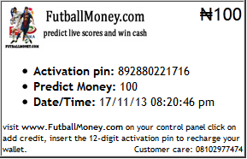  
12 Digit Pin Access key Activation pin ranges  
₦100 ₦200 ₦400 ₦500 ₦1000... and Above

### If you have any question, call the customer service line on 0810-297-7474,

### 0815-999-7140.

### 10AM To 4PM Mondays To Fridays.

Customer Service: [futballmoney.com/contact.php](http://www.futballmoney.com/contact.php)

facebook: [www.facebook.com/futballmoney](http://www.facebook.com/futballmoney)

Twitter: [www.twitter0.com/futballmoney](http://www.twitter0.com/futballmoney)

## End-User License Agreement (EULA)

By installing or using the licensed software FutballMoney from RomatechICTSolutions Ltd, the individual if acting on behalf of himself or herself (“individual customer“) or the individual who is acting on behalf of an educational or nonprofit institution, governmental agency, or other (“entity customer”, the individual customer and entity customer together are ”customer”) is agreeing to be bound by this software license agreement (“agreement”).

If customer does not agree to this agreement, customer may not install, copy, or use the licensed software.

Copyright 2014 @ RomatechICTSolutions Ltd